Project Proposal: "Dishly"
Overview
Dishly is a website for those of us who love to cook new dishes and try new foods but do not have the natural talent for remembering various recipes or experimenting with what we have. This app allows you to search for a recipe you know by name but just can’t remember the details, or giving you options to spice up a recipe you know by name but want to see how others make it. If you find something that you like, you simply save it and come back for it later.

Target Audience
This application is aimed at anyone who likes food, likes to cook, and everyone else because we all have to eat. Those who might find it particularly useful are:
• Couples looking for a cook-in date night
• Families who need to break up the dinner routine.
• Busy individuals looking to meal prep.

Major Functions
1. Search for recipes where the user can make a request to the API to fetch recipes by name
2. Save a recipe to a list of their favorite recipes to try again later.
3. List ingredients so the user can have a convenient location detailing what they need to make it.
4. Ingredient information where they can request additional nutritional information on specific ingredients
5. Get recipe instructions so they can follow along step by step
6. Get nutritional information to provide details such as calories, fat, protein, etc for the recipe as a whole.
7. Filter recipe type will allow the user to select recipe types, such as Main Dishes or Appetizers.
8. Display saved recipes shows a list of recipe summaries to quickly choose from the user’s saved dishes

Wireframes
Desktop view
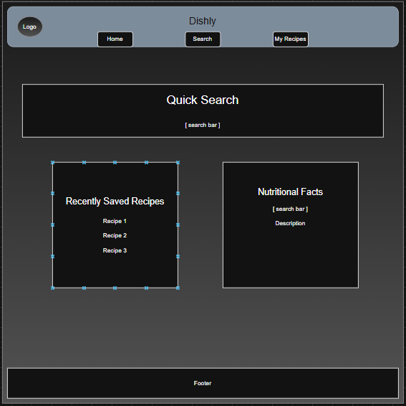

Mobile View
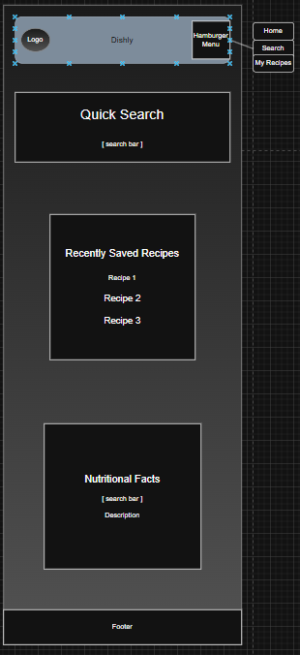
External Data
• fatsecret Platform API: Database for food and recipe information including nutritional data and instructions - https://platform.fatsecret.com/
• FoodData Central API: U.S. Department of Agriculture resource for searching nutritional information on individual food items to accompany the recipes - https://fdc.nal.usda.gov/api-guide
• Local Storage: To store user’s saved recipe list.

Module List
• UI Module: Handles all user interface elements. Renders and displays the user’s queries and saved recipes.
• API Module: Requesting data from the APIs to make available to the user on the recipes and nutritional information
• Event Handling Module: Processes user requests for forms and button clicks.
• Data Management Module: Stores and retrieves the user’s data with local storage.

Graphic Identity
• Color Scheme: A lighter background with vibrant greens for the primary color and light yellows as an accent to emphasize the theme of health, growth, and self-care.
• Typography: Bolder style sans fonts for headers and mostly use of a more moderate sans font style for the majority of body and informational text.
• Application Icon: A small lemon tree following the color scheme of the website


Timeline (Weeks 5-7)
• Week 5:
o Complete HTML skeleton layout of the web pages.
o Style the pages with CSS and provide navigational links.
o Implement the API module to test retrieving recipes and nutritional information.
• Week 6:
o Build recipe search functionality with JavaScript to grant user access to the API
o Integrate localstorage to allow saving of recipes
o Add the individual ingredient API request functionality
• Week 7:
o Refine JavaScript and API interactions to clean up data requests and rendering
o Touch up CSS to accommodate API requests
o Deploy the application and submit the project.

Project Planning
Trello Board
https://trello.com/b/ch9NjCBP/dishly

Challenges
The biggest challenges that I anticipate will be involving the APIs. I am expecting the largest obstacle here will be getting the queries to process as I expect them to and to be able to format the data that I receive back in such a way that it will render properly when I then try to format it onto the viewport.

